[**DOING PHYSICS WITH MATLAB**](http://www.physics.usyd.edu.au/teach_res/mp/mphome.htm)

**QUANTUM PHYSICS**

**HYDROGEN ATOM**

**HYDROGEN-LIKE IONS**

Ian Cooper

School of Physics, University of Sydney

ian.cooper@sydney.edu.au

[**DOWNLOAD DIRECTORY FOR MATLAB SCRIPTS**](http://www.physics.usyd.edu.au/teach_res/mp/mscripts)

**qp_hydrogen.m**

Main program for solving the Schrodinger Equation for hydrogen-like atoms and ions. Calls **simpson1d.m** to calculate the integral of a wavefunction.

**qp_azimuthal.m**

mscript for plots of the real and imaginary parts of the azimuthal wavefunction.

**qp_legendre.m**

There is a Matlab function **legendre(n, cos*θ* )** to compute the associated Legendre functions , where *l* is the degree of the function and *ml* = 0, 1, 2, … *l* is the order where *n* = *l* + 1. The angle *θ* is measured with respect to the Z axis and has a range from 0 to π rad. Polar diagrams of the directional dependence of the associated Legendre functions and corresponding probability densities for different orbits are produced for the angular wavefunction.

**qp_pot.m**

mscript for plotting the potential energy functions *Ueff*, *Uc* and *Ul* for *l* = 0, 1, 2, 3.

**qp_bohr.m**

mscript for calculating the theoretical values of the total energy *E* from Bohr’s equation.

**qp_lithium.m**

mscripts for plotting the probability function for the neutral lithium atom using the data stored in the file **qp_hL.mat**

**qp_lithium.m**

Mscript for a plot of the line spectrum for the Balmer series.

Hydrogen is the simplest of all the atoms with only one electron surrounding the nucleus. Ions such as He+ and Li2+ are *hydrogen-like* since they also have only a single electron.

In each case, the mass of the electron is much less the nuclear mass, therefore, we will assume a stationary nucleus exerting an attractive force that binds the electron to the nucleus. This is the Coulomb force with corresponding potential energy *Uc*(*r*) is

(1) 

*depends only on the separation distance r between the electron and proton*

The Coulomb force between the nucleus and electron is an example of a central force where the attractive force on the electron is directed towards the nucleus. This is a three dimensional problem and it best to use **spherical coordinates** (*r*  *θ*  *φ*) centered on the nucleus as shown in figure 1. The **radial coordinate** is *r*, *θ* is the **polar angle (0 to π)** and *φ* is the **azimuthal angle (0 to 2π)**.



Fig. 1. Spherical coordinates of the electron (*r*, *θ*, *φ*) centered on the nucleus. The distance between the electron and nucleus is *r*, *θ*  is the angle between the *Z* axis and the radius vector and *φ* is the angle between the *X* axis and the projection of the radius vector onto the *XY* plane. *θ* ranges from 0 to π and the azimuthal angle *φ* from 0 to 2π.

The time independent Schrodinger Equation in spherical coordinates can be expressed as

(1) 

where *μ* is the reduced mass of the system



The time independent wavefunction *ψ* in spherical coordinates is given by

(2) 

Equation (1) is separable, meaning a solution may be found as a product of three functions, each depending on only one of the coordinates *r*, Θ, Φ. This substitution allows us to separate equation (1) into **three** separate differential equations (equations 4, 6 and 7) each depending on one coordinate *r*, Θ, Φ. For physical acceptable solutions to these three differential equations it requires three quantum numbers:

**principle quantum number *n*** = 1, 2, 3 …

(3) **orbital angular momentum quantum number *l***= 0, 1, 2, … *n*-1

**magnetic quantum number *ml***= 0, ± 1, ± 2, … , ± *l*

**Azimuthal equation**

The differential equation in Φ is known as the **Azimuthal equation** can be written

(4)  ***azimuthal equation***

The solution of the azimuthal equation (equation 4) is

(5)  *solution not normalized*

The function  has a period of 2π and since all physical quantities are derived from the wavefunction, the wavefunction must be singled valued for *φ* = 0 and 2π. This means that the only physically acceptable solutions for *ml* are *ml* = 0, ±1, ±2, ±3, … .



The real part of  is a cosine function and the imaginary part is a sine function. When *ml* = 0 then . *ml* gives the number of complete cycles of the azimuthal function within the range 0 to 2π for *φ* (figure 2).

It is easy to write a Matlab script to plot the real and imaginary part of the azimuthal wavefunction Φ(*φ*). Figure (2) shows a few sample plots. The m-script **qp_azimuthal.m** calculates and plots Φ(*φ*) against *φ*.

% qp_azimuthal.m

% Plot for the solution to the Azimuthal differential equation

clear all; close all; clc;

ml = 2; % change the value of ml to the required value

phi = linspace(0,1,500).* (2*pi);PHI = exp(j .* ml .* phi);

figure(1)

set(gcf,'Units','Normalized');

set(gcf,'Position',[0.2 0.15 0.2 0.2])

set(gca,'fontsize',8);

x = phi./(2*pi); y1 = real(PHI); y2 = imag(PHI);

plot(x,y1,'linewidth',2);hold on;

plot(x,y2,'r','linewidth',2); grid on;

xlabel('azimuthal angle \phi / 2\pi')

ylabel('azimuthal wavefunction \Phi')

title_m = ['m_l = ', num2str(ml)];

title(title_m);

|  |  |
| --- | --- |
|  |  |
|  |  |

Fig. 2. Azimuthal wavefunction Φ(*φ*): real part a cosine function (blue) and imaginary part a sine function (red). The azimuthal function is single valued at *φ* = 0 and *φ* = 2π rad. [**qp_azimuthal.m**]

**Angular equation**

The differential equation for  is called the ***angular equation***

(6)  ***angular equation***

Note that the angular equation (equation 6) depends upon the quantum numbers *ml* and *l*. For physically acceptable solutions of equation (6) there must be restrictions on *ml* and *l* as given by equation (3). That is, the quantum number *l* must be a zero or a positive integer, and the quantum number *ml* must be a positive or negative integer or zero and .

The solution of the angular equation was first worked out by the famous mathematician Adrien Legendre (1752 – 1833). Equation (6) is often called the **associated Legendre equation**.

The solutions for the angular equation are polynomials in cos*θ* known as the ***associated Legendre polynomials*** 

where *l* = 0, 1, 2, … and *ml* = 0, ±1, ±2, ±3, … . 

The normalized solution to equation (6) can be written as



where is a appropriate normalization constant such that



It is customary for historical reasons to use letters for the various values of *l*.

|  |  |  |  |  |  |  |
| --- | --- | --- | --- | --- | --- | --- |
| *l* | 0 | 1 | 2 | 3 | 4 | 5 |
| letter | s | p | d | f | g | h |

The letters arose from visual observations of spectral lines: **s**harp, **p**rinciple, **d**iffuse, and **f**undamental. After *l* = 3 (f state), the letters generally follow the order of the alphabet.

Atomic states are normally referred to by the number *n* and the *l* letter. For example, *n* = 2 and *l* = 1 is called a 2p state.

There is a Matlab function **legendre(L, cos*θ* )** to compute the associated Legendre functions , where *l* is the degree of the function and *ml* = 0, 1, 2, … *l* is the order. The angle *θ* is measured with respect to the Z axis and has a range from 0 to π rad.

For example in the Matlab Command Window:

**legendre(2,0)** returns the vector [-0.5 0 3]

|  |  |  |  |
| --- | --- | --- | --- |
| ***l* = 2 *θ* = π/2 cos*θ* = 0** | | | |
| *ml* | 0 | 1 | 2 |
|  | -0.5 | 0 | 3 |

The m-script **qp_legendre.m** computes and plots the associated Legendre functions. Figure 3 shows polar diagrams of the directional dependence of the associated Legendre functions and corresponding probability densities for different orbits.

Fig. 3. Polar diagrams for the associated Legendre polynomials and directional dependence for the probability density functions for various values of *l* and . For the probability density curves, the length of the straight line from the origin to any point on a given curve is proportional to the probability that the electron is in the direction of that line. All values of P(*l*,|*ml*|) and P2(*m*,|*ml*|) have normalized to 1. Note the way in which the regions of higher probability shifts from the Z axis to the XY plane as  increases. In the ground state (*n* = 0 *l* = 0 *ml* = 0) of a one-electron atom, the function  depends neither on *θ* nor *φ* and the probability density is spherically symmetrical. For states with *ml* = 0 and *l* ≠ 0 there is a higher probability density concentration along the Z axis (near *θ* = 0o and 180o). For states with , the concentration of probability density in the XY plane (near *θ* = 90o) becomes more and more pronounced with increasing values of *l* and the ± gives the alignment of higher probability concentrations along either the X or Y axis. A [3D] view can be imaged by rotating the patterns around the Z axis. If all the probability densities for a given *n* and *l* are combined, the result is spherically symmetrical.

[**qp_legendre.m]**

|  |
| --- |
|  |
|  |
| *ml* = -1 orbital aligned along X axis *ml* = +1 orbital aligned along Y axis |
|  |
|  |
|  |
|  |
| ` |
|  |
|  |
|  |
|  |
|  |
|  |
|  |

The products describing the angular dependence of the wavefunction are known as the ***spherical harmonics*** . The functions  are polynomials in sinθ and cosθ of order *l*.

Because the angular equation contains *l* and *ml* as well, the solutions to the azimuthal and angular equations are linked. It is customary to group these solutions together into what is called the ***spherical harmonics*** 



**Radial equation**

Finally, to complete the process, **the *radial equation***becomes

(7)  ***radial equation***

Equation (7) is also known as the ***associated Laguerre equation*** after the French mathematician Edmond Laguerre (1834 – 1886). The ***associated* *Laguerre functions*** are the solutions of the radial equation and are polynomials in *r*.

The differential equations in *φ* (equation 4) and in *θ* (equation 6) are independent of the potential energy function *Uc*(*r*). The total energy *E* and the potential energy *Uc*(*r*) appear only in the radial differential equation (equation 7). Therefore, it is only the radial equation (equation 7) containing the potential energy term *Uc*(*r*) that determines the allowed values for the total energy *E*.

Physically acceptable solutions of the radial equation (equation 7) for hydrogen atom and hydrogen-like ions can only be found if the energy *E* is quantized and has the form

(8)  *total energy is quantized*

where the principal quantum number is *n* = 1, 2, 3, … and *n* > *l*. The negative sign indicates that the electron is bound to the nucleus. If the energy were to become positive, then the electron would no longer be a bound particle and the total energy would no longer be quantized. The quantized energy of the electron is a result of it being bound to a finite region. The energy levels of the hydrogen atom depend only on the principle quantum number *n* and do not depend on any angular dependence associated with the quantum numbers *l* and *ml*. Equation (8) is in agreement with the predictions of the Bohr model. In the **Bohr Model** of the atom the total energy *En* is quantized and the electron can only orbit without radiating energy in stable orbits of fixed radii *rn* given by equation (9).

(9)  *Bohr model: allowed stable orbits*

For hydrogen-like species, the total energy depends only on the principal quantum number *n*, this is not the case for more complex atoms. The ground state is specified by the unique set of quantum *n* = 1, *l* = 0, *ml* = 0. For the first excited state there are four independent wavefunctions with quantum numbers:

*n* = 2 *l* = 0 *ml* = 0

*n* = 2 *l* = 1 *ml* = -1

*n* = 2 *l* = 1 *ml* = 0

*n* = 2 *l* = 1 *ml* = 1

This means that the first excited state is ***four-fold degenerate*** as the total energy *E*2 only depends on the principle quantum number *n*.

We can define a pseudo-wavefunction ***g*(*r*) = *r* *R*(*r*)** which leads to a one dimensional Schrodinger Equation

(10) 

where the effective potential energy *Ueff* has two contributions due to the Coulomb interaction *Uc* and the angular motion of the electron *Ul*

(11) 

The Matlab mscript **qp_pot.m** can be used to plot the potential energy functions as shown in figure (4).

|  |  |
| --- | --- |
|  |  |
|  |  |

Fig. 4. Plots of the potential energy functions *Ueff*, *Uc* and *Ul* for *l* = 0, 1, 2, 3.

[**qp_pot.m**]

**Probability Distribution Function**

In the Bohr theory of the hydrogen atom, the electron was pictured as orbiting around the nucleus in a simple circular orbit. The position vector of the electron was well defined. However, in quantum terms the electron’s position is not well defined and we must use the wavefunction to calculate the probability distribution of the electron in the state (*n* *l* *ml*).

Also, in many applications in atomic physics it is important to know the behaviour of the wavefunctions since measureable quantities can be obtained by calculating various expectation values.

From the wavefunction of a given state (*n l ml*), we can calculate the probability of finding an electron from the corresponding ***probability density function***

(12) 

The probability of finding the electron does not depend upon the azimuthal angle *φ* since

(13) 

hence

(14) 

The distribution gives a uniform probability – all values of *φ* are equally likely.

The angular distribution functions and probability density functions are shown in figure 3.

The radial wavefunction *Rnl*(*r*) can be used to calculate the radial probability distribution of the electron, that is, the probability of the electron being at a distance *r* from the nucleus and it depends on both *n* and *l*.

We are interested in finding the probability *P*(*r*)*dr* of the electron being in a thin shell of radius *r* and thickness *dr*. The differential volume element in spherical polar coordinates is

(15) 

Therefore,

(16) 

We integrate over *θ* and φ because we are only interested in the radial dependence. Using the pseudo-wavefunction *g*(*r*) = *r* *R*(*r*) and letting *N* be a normalizing constant, the probability of finding the electron with the thin shell reduced to

(17) 

where

(18) 

since the probability of finding the electron is one.

**Solving the Schrodinger Equation**

Matlab mscripts can be used to find solutions of the Schrodinger Equation. The angular dependence is determined by evaluating the associated Legendre functions using the Matlab function **legendre(n, cos*θ* )**. The radial equation given by equation (9) can be solved using the [Matrix Method](http://www.physics.usyd.edu.au/teach_res/mp/doc/qp_se_matrix.pdf).

The mscript **qp_hydrogen. m** can be used to solve the Schrodinger Equation for the hydrogen atom and hydrogen like ions. When the mscript **qp_hydrogen. m** is run, the following is shown requesting various inputs:

max radial distance (default 10e-10 m), r_max =

orbital quantum number (default 0), L = 0

magnetic quantum number (default 0), m_L = 0

nuclear charge (default 1), Z = 1

Enter Principal Quantum Number for calculation of expectation values and graphical display

Enter Principal Quantum Number (n > L), n =

The Command Window output after the mscript has finished executing is:

No. bound states found = 5

Quantum State / Eigenvalues En (eV)

1 -13.586

2 -3.3972

3 -1.5098

4 -0.81674

5 -0.21545

Principal Quantum Number, n = 3

Orbital Quantum Number, L = 0

Magnetic Quantum Number, m_L = 0

Nuclear charge, Z = 1

Energy, E = -1.50983

Total Probability = 1

r_peak = 6.93334e-10 m

<r> = 7.1458e-10 m

<r^2> = 5.79647e-19 m^2

<ip> = 2.43256e-29 N.s

<ip^2> = 4.40938e-49 N^2.s^2

<U> = -3.02182 eV

<K> = 1.51082 eV

<E> = -1.511 eV

<K> + <U> = -1.511 eV

deltar = 2.62721e-10

deltaip = 6.64031e-25

(dr dk)/hbar = 1.6536

execution time = 17.4 s

There are some problems with the accuracy of the Matrix Method due to the maximum range for the radial coordinate *rmax*. If *rmax* is too small than the energy eigenvalues near the top of the potential well will be inaccurate. However, if *rmax* is large, then the numerical procedure has difficulties in calculating the eigenvalues. The real potential diverges to infinity as *r* approaches zero. In our modelling, the potential energy function is truncated at some value of *r*. Table 1 gives the energy eigenvalues in eV for different values of *rmax* (x10-10 m). The theoretical values for *E* are calculated from equation (8) using the mscript **qp_bohr.m** .

Table 1

|  |  |  |  |  |  |
| --- | --- | --- | --- | --- | --- |
| State (*n l ml*) | *E* (theory) | *rmax* = 10 | *rmax* = 20 | *rmax* = 30 | *rmax* = 50 |
| (1 0 0) | -13.5828 | -13.578 | -13.586 | -13.582 | -13.5680 |
| (2 0 0) | -3.3957 | -3.3952 | -3.3972 | -3.3969 | -3.3961 |
| (3 0 0) | -1.5092 | -1.2867 | -1.5098 | -1.5099 | -1.5097 |
| (4 0 0) | -0.8489 | --- | -0.81674 | -0.84919 | -0.84929 |
| (5 0 0) | -0.5433 | --- | -0.21545 | -0.52374 | -0.54356 |
| (6 0 0) | -0.377 | --- | --- | -0.20996 | -0.37605 |
| (7 0 0) | -0.2772 | --- | --- | --- | -0.24948 |
| (8 0 0) | -0.2122 | --- | --- | --- | -0.093909 |
| (2 1 0) | -3.3957 | -3.3980 | -3.3984 | -3.3985 | -3.3986 |
| (3 1 0) | -1.5092 | -1.3537 | -1.5103 | -1.5104 | -1.5104 |

For larger *n* values the maximum radial coordinate must be large otherwise the results are inaccurate because for large *n* values the electron is most likely to be found at large distances from the nucleus.

The energy spectrum for the hydrogen atom is shown in figure 5.

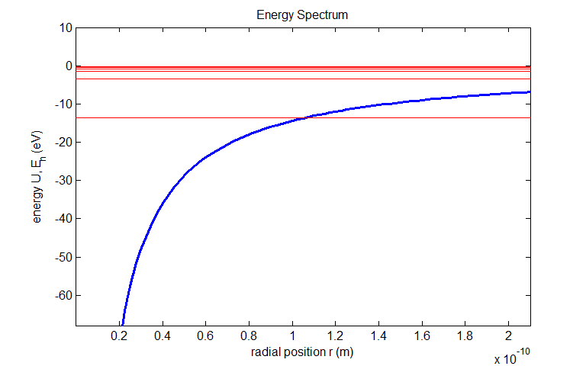

Fig.5. The Coulomb potential *Uc* and the energy eigenvalues *En* for a hydrogen atom. For large values of *n* the eigenvalues become very closely spaced in energy since *En* approaches zero as *n* approaches infinity . The intersection of the curves for *Uc* and *En* which defines one end of the classically allowed region moves out as n increases.

[**qp_hydrogen.m**]

Although the wavefunction is not a measureable quantity, we can use this function to calculate the expected result of the average of many measurements of a given quantity – this result is known as the **expectation value**. Any measurable quantity for which we can calculate the expectation value is called a **physical observable**. The expectation values of physical observables must be real because experimental measurements are real quantities. See the document on [Matrix Methods](http://www.physics.usyd.edu.au/teach_res/mp/doc/qp_se_matrix.pdf) for details of calculating expectation values.

We will consider the quantum predictions for the ground state of the hydrogen atom using the Matlab mscript **qp_hydrogen.m**.

Ground state is specified by the quantum numbers *n* = 1 *l* =0 *ml* = 0

Maximum radial distance used in the simulation *rmax* = 20x10-10 m

Eigenvalue energy *E*1 = -13.5858 eV (Theoretical value *E*1 = -13.5828 eV)

Expectation value for kinetic energy of electron <*K*> = 13.5624 eV

Expectation value for potential energy of system <*U*> = -27.1729 eV

Expectation value for the total energy <*E*> = -13.6104 eV

where <*K*> + <*U*> = -13.6104 eV

The expectation value for the total energy <*E*> should equal the eigenvalue energy *E*1 with Δ*E* = 0 since the electron is in a stationary state.

*E*1 = -13.5858 eV <*E*> = -13.6104 eV

The discrepancy between the two values is a result of numerical and model inaccuracies.

Radial position for maximum probability concentration *rpeak* = 0.5333x10-10 m

Bohr radius *a*0 = 0.5292x10-10 m

Expectation value for radial position of electron <*r*> = 0.7948x10-10 m

Uncertainty in expected radial position of electron Δ*r* = 0.4589x10-10 m

Average value for radial position of electron *ravg* = (0.79 ± 0.46)x10-10 m

The radial position for the maximum probability concentration corresponds to radius of the allowed stable orbit given by the Bohr theory. The average position of the electron has a value greater than the Bohr radius. Figure (6) shows a graphical output for the calculation of the expectation position for the radial position *r*.

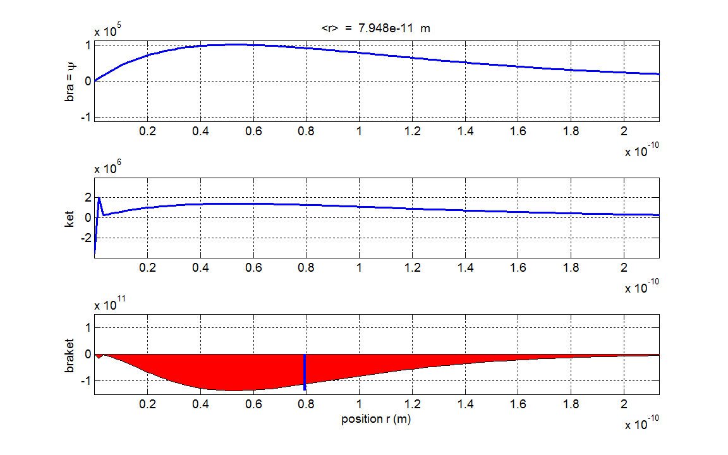

Fig. 6. Graphical output for the calculation of the radial position *r*. The graph shows the expectation value <r> = 0.7948x10-10 m and the most probable position (location of highest probability concentration) at the Bohr radius a0 = 0.5292x10-10 m. [**qp_hydrogen.m**]

Expectation value for momentum <*ip*> = 6.5557x10-28 m N.s

The expectation value for the momentum is imaginary, therefore, we can conclude that the linear momentum of the electron is zero <*p*> = 0 N.s

The He**isenberg’s uncertainty principle** applies to our one-electron system



Uncertainty in momentum of the electron Δ*ip* = 1.9895x10-24 N.s

Uncertainty in expected radial position of electron Δ*r* = 0.4589x10-10 m



Therefore, in our simulation, the uncertainty principle is satisfied.

The radial wavefunction and radial probability density function depend upon the quantum number *n* and *l* but not *ml*. Figure (7) shows radial wavefunctions and radial probability density functions for the electron in a one-electron atom for differing (*n l*) combinations.

Fig. 7. Plots of the radial wavefunctions and radial probability density functions for the electron in a one-electron atom for differing (*n l*) combinations .

**state 1s *n* = 1 *l* = 0** 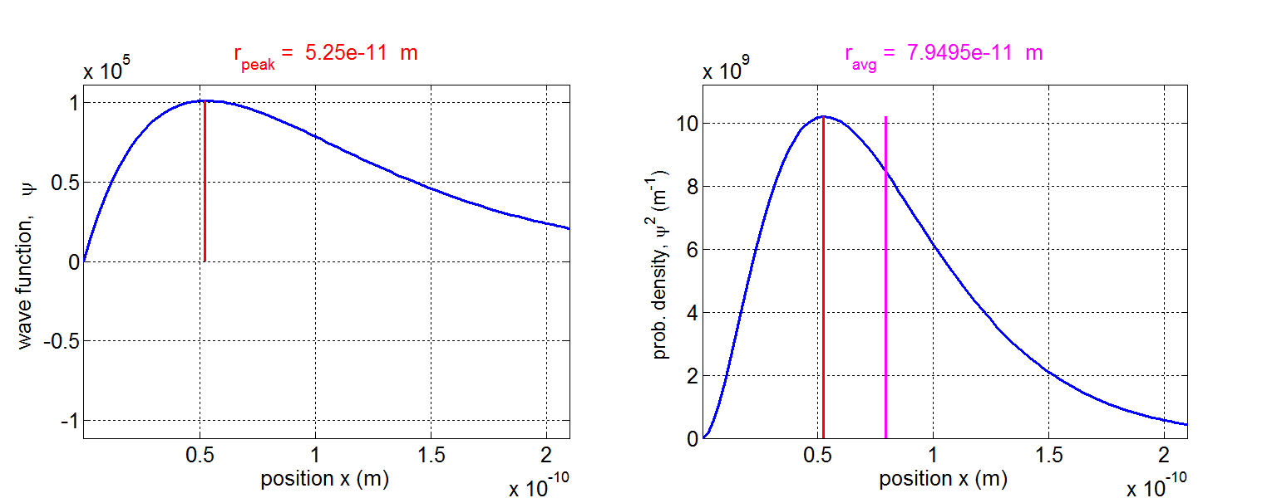

**state 2s *n* = 2 *l* = 0**

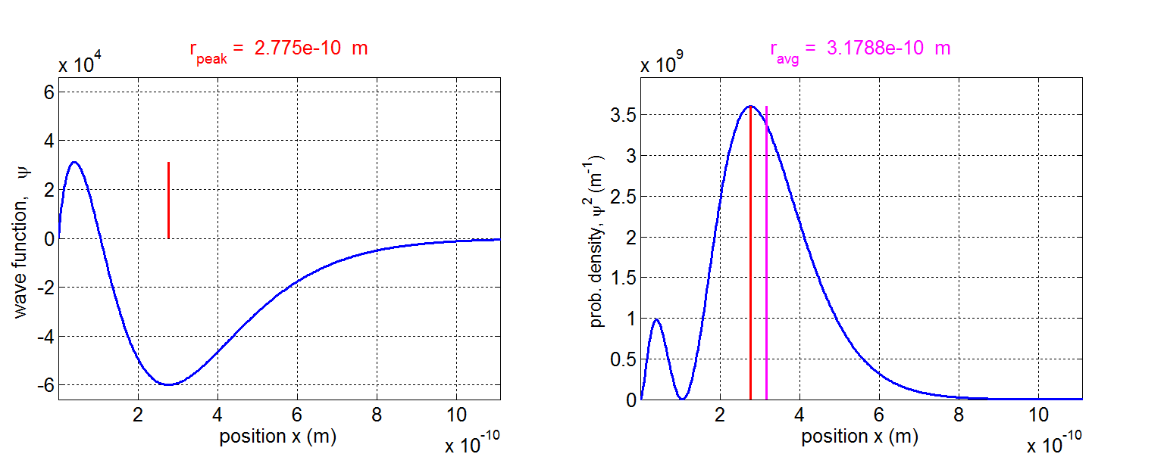

**state 2p *n* = 2 *l* = 1** 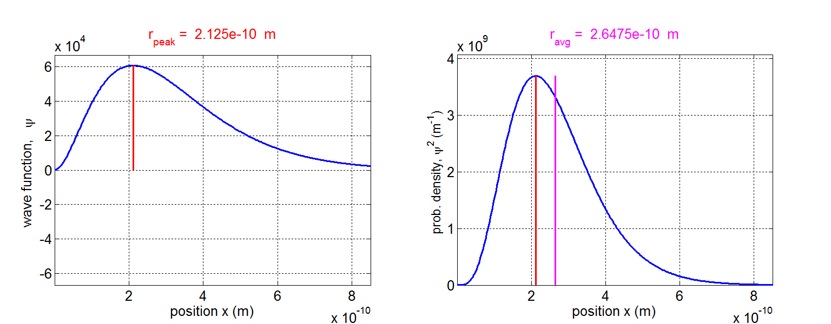

**state 3s *n* = 3 *l* = 0** 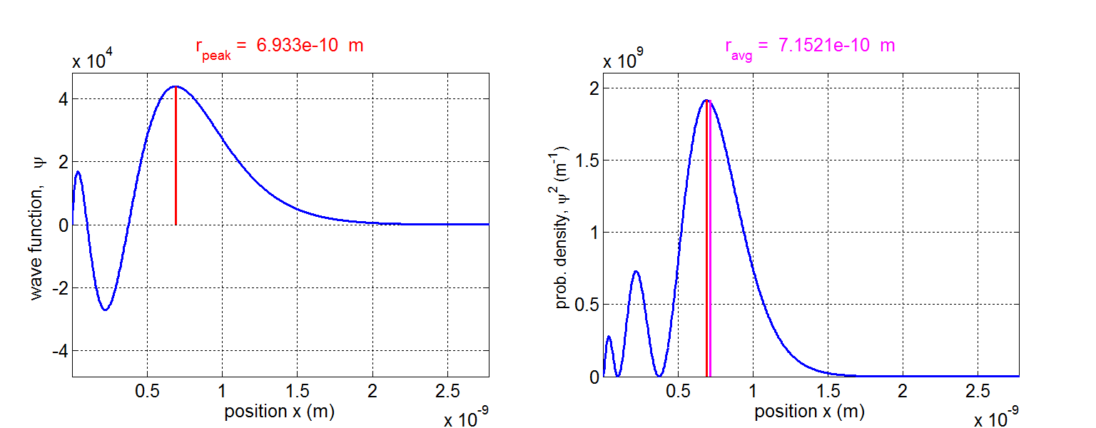

**state 3p *n* = 3 *l* = 1** 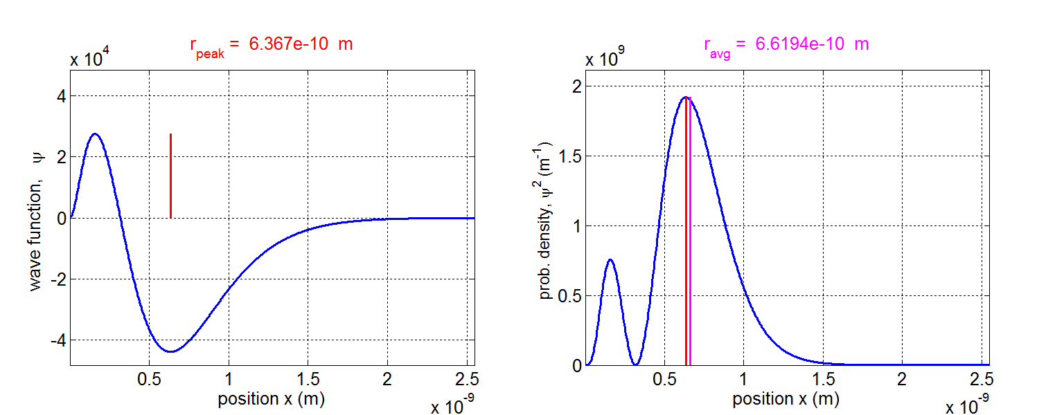

**state 3d *n* = 3 *l* = 2** 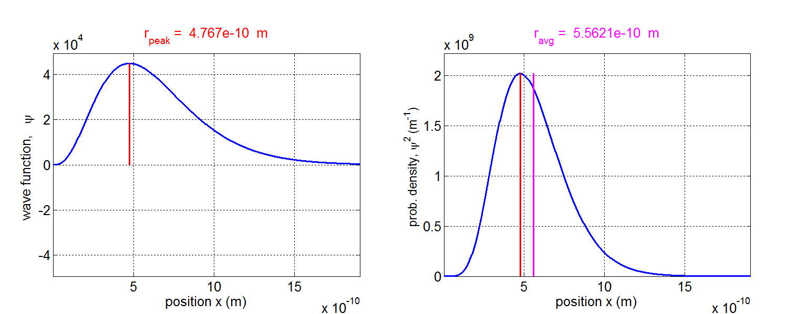

**state 4s *n* = 4 *l* = 0** 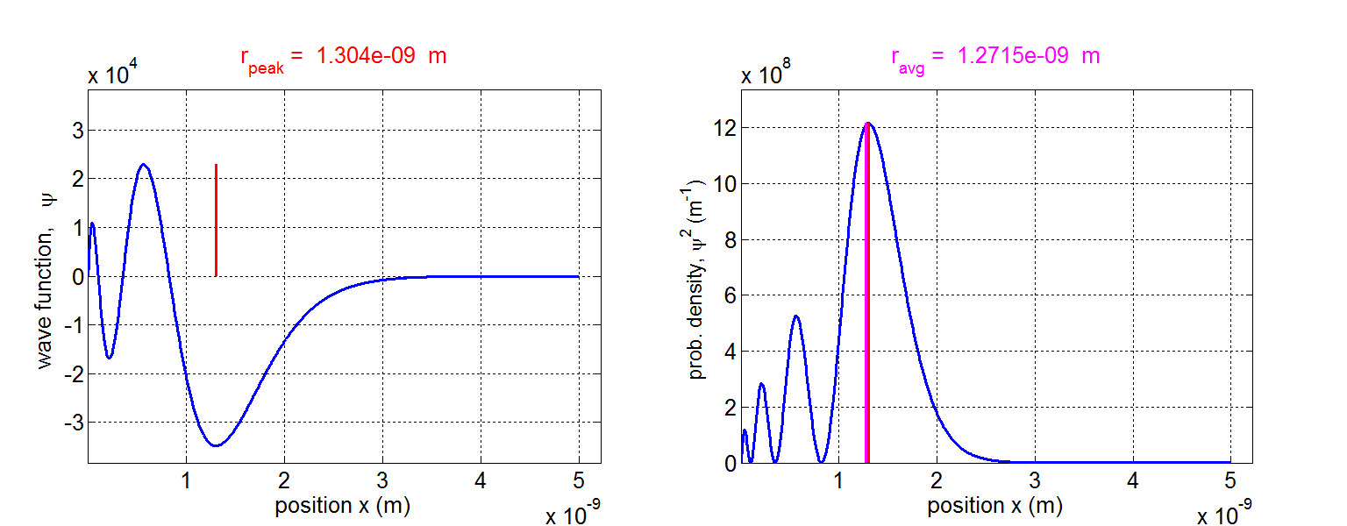

**state 4p *n* = 4 *l* = 1** 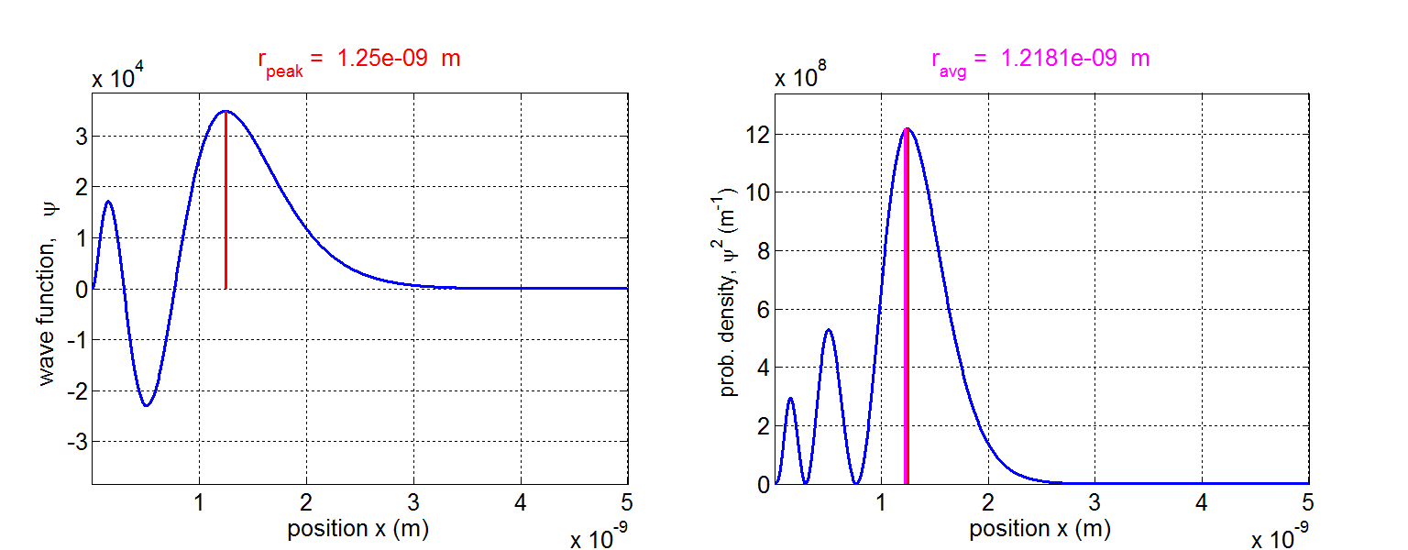

**state 4d *n* = 4 *l* = 2** 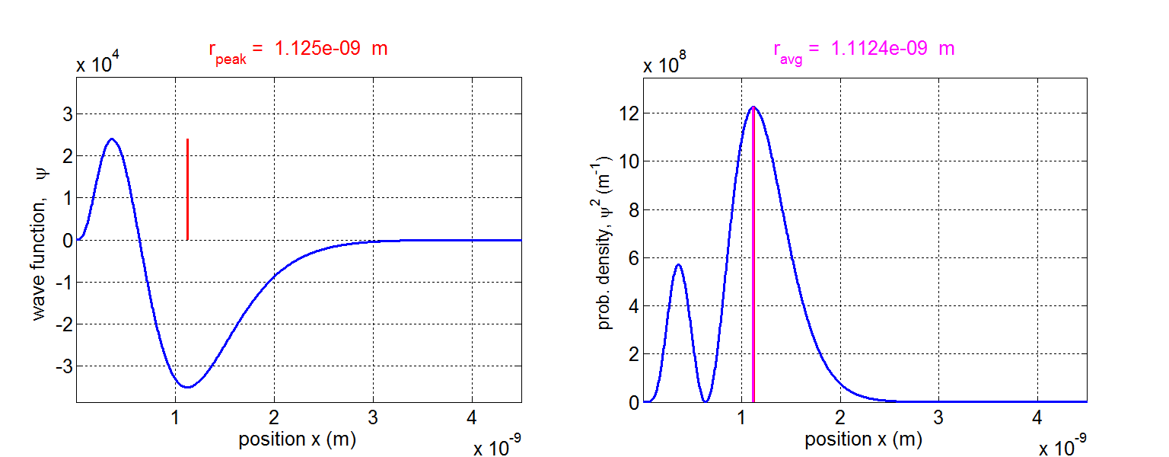

**state 4f *n* = 4 *l* = 3** 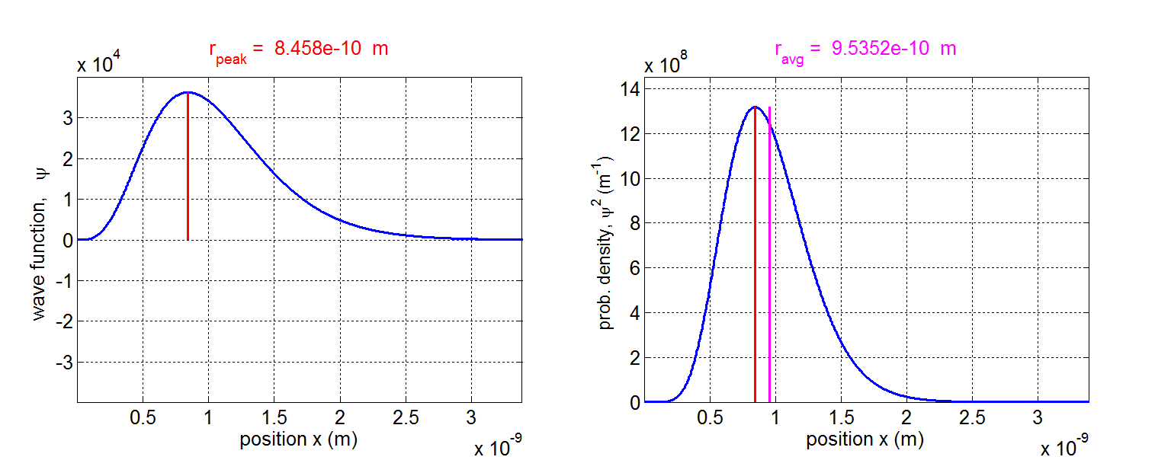

For a state ( *n l* ), the number of peaks in the probability density plots is ( n - *l* ), for example, the shell *n* = 4:

|  |  |  |
| --- | --- | --- |
| **subshell** | ***l*** | **No. peaks** |
| s | 0 | 4 |
| p | 1 | 3 |
| d | 2 | 2 |
| f | 3 | 1 |

Inspection of the plots show that the radial probability for a given combination of (*n l*) have appreciable values only in restricted ranges of the radial coordinate, hence, the electron is most likely to be found within a thin shells region surrounding the nucleus. The radius of each shell is mainly determined by the principle quantum number *n* and with a small angular *l* dependence.

The Bohr model of the hydrogen-like atoms gives allowed stable circular orbits of radii

(19) 

Solutions of the Schrodinger Equation show that radii of the shells are of approximately the same size as the circular Bohr orbits. The total energy becomes more positive with increasing *n*, so the region of the radial coordinate *r* for which *E* > *U*(*r*) is greater with increasing *n*, that is, the shells expand with increasing *n* because the classically allowed regions expand.

Figure 7 shows that the details of the structure of the radial probability density functions do depend upon the value of the orbital angular momentum quantum number *l*. For a given *n* value, the probability density function has a strong single maximum when *l* has its largest possible value. When *l* takes on smaller values, additional weaker maxima develop inside the strong one. The smallest value of *l* gives the most number of maxima. When *l* = 0 there is a higher probability of the electron being in the region near the origin (*r* = 0), this means that only for s states (*l* = 0) will there be an appreciable probability of finding the electron near the nucleus.

A summary of the Bohr radii *rBohr*, the expectation values *ravg* and radii for the most probable location *rMost Prob* for different combinations of *n* and *l* given in Table 2.

Table 2.

|  |  |  |  |  |
| --- | --- | --- | --- | --- |
| State (*n l ml*) | *rmax*  (x10-10 m) | *rBohr*  (x10-10 m) | *rMost Prob*  (x10-10 m) | *ravg*  (x10-10 m) |
| 1s (1 0 0) | 30 | 0.53 | 0.53 | 0.80 |
| 2s (2 0 0) | 30 | 2.21 | 2.77 | 3.18 |
| 2p (2 1 0) | 30 | 2.21 | 2.12 | 2.65 |
| 3s (3 0 0) | 40 | 4.77 | 6.93 | 7.15 |
| 3p (3 1 0) | 40 | 4.77 | 6.37 | 6.62 |
| 3d (3 2 0) | 40 | 4.77 | 4.77 | 5.56 |
| 4s (4 0 0) | 50 | 8.48 | 13.04 | 12.72 |
| 4p (4 1 0) | 50 | 8.48 | 12.5 | 12.18 |
| 4d (4 2 0) | 50 | 8.48 | 11.25 | 11.24 |
| 4f (4 3 0) | 50 | 8.48 | 8.46 | 9.54 |

For a given *n* value, the radius *rMost Prob* at which has the highest probability concentration agrees most closely with the Bohr radius *rBohr* is the state with the highest value of *l* and is the probability density function which has a single peak at a smaller value of *r* than those states with smaller *l* values. For a given *n* value, the average radial distance *ravg* from the nucleus increases with decreasing *l* values.

Figure 8 shows two-dimensional views of the probability density functions for different electron states (*n* *l* *ml*) of the hydrogen atom. To image a three-dimensional view rotate the image through 360o, there being axial symmetry about the Z axis in each case. The binding energy *EB* = -*E* is the energy to remove the electron from the atom is displayed in each plot.

Fig. 8. Two-dimensional representation of the probability density functions.





**state 1s *n* = 1 *l* = 0 *ml* = 0**

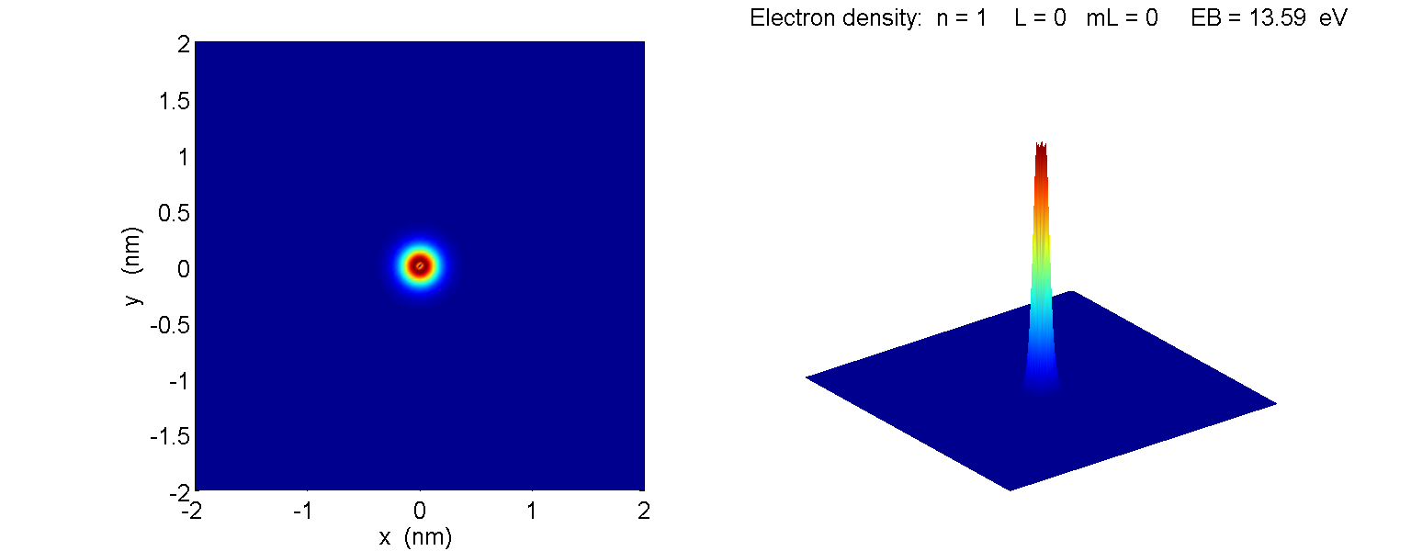

**state 2s *n* = 2 *l* = 0 *ml* = 0** 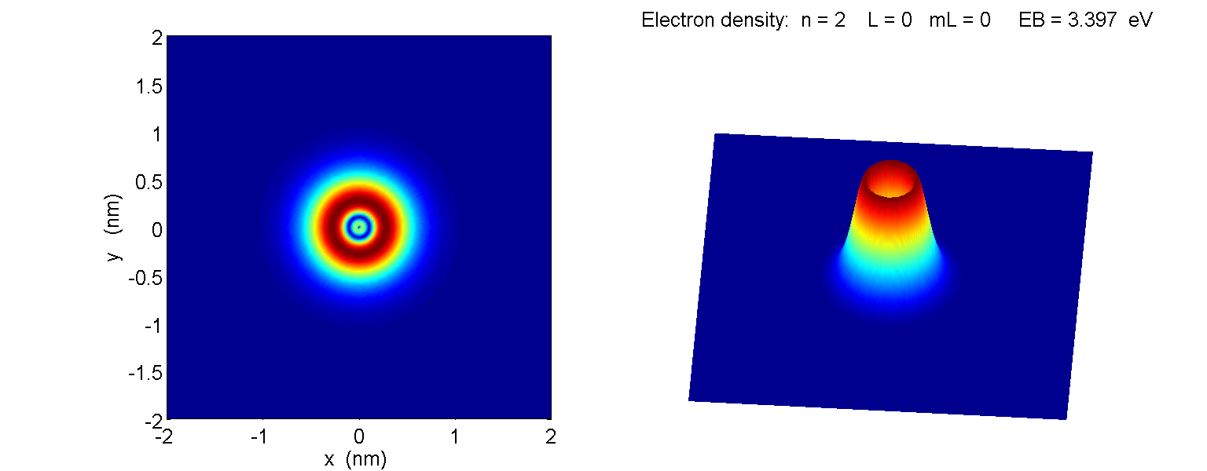

**state 2p *n* = 2 *l* = 1 *ml* = 0** 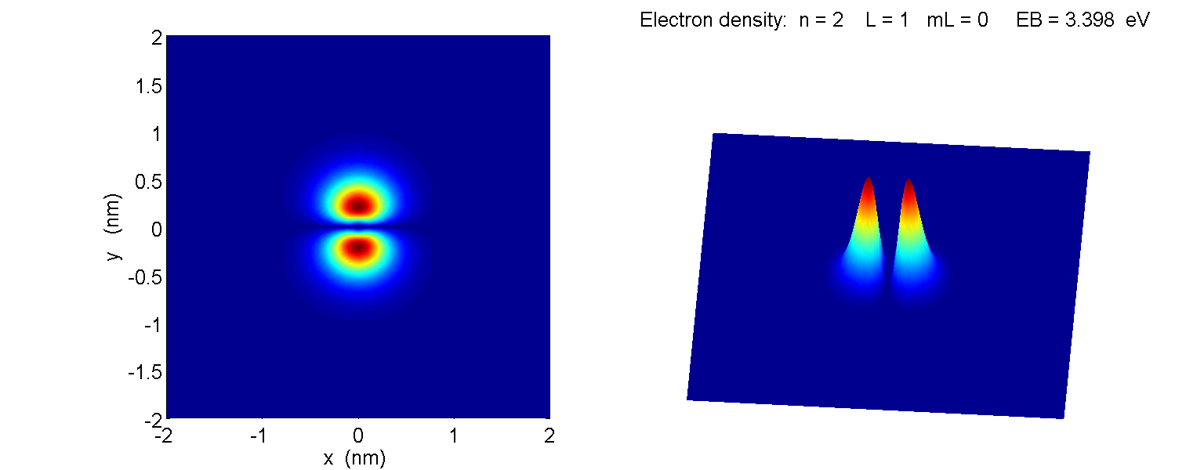

**state 2p *n* = 2 *l* = 1 *ml* = ±1** 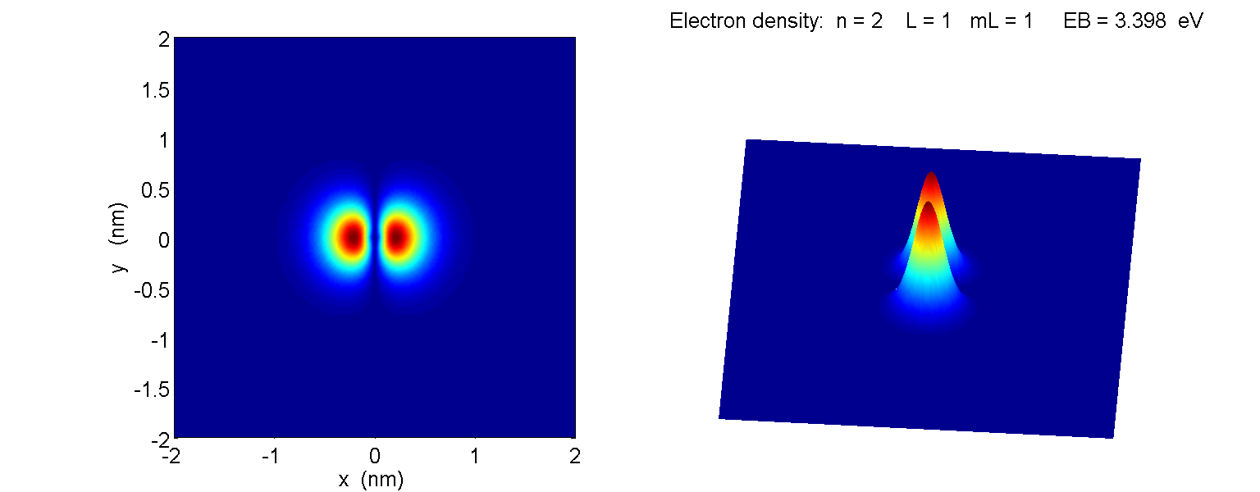

**state 3s *n* = 3 *l* = 0 *ml* = 0** 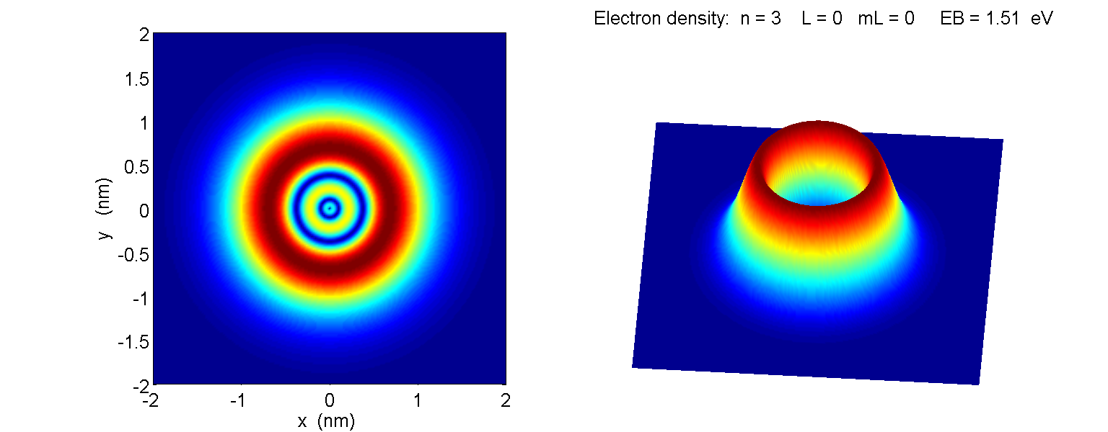

**state 3p *n* = 3 *l* = 1 *ml* = 0** 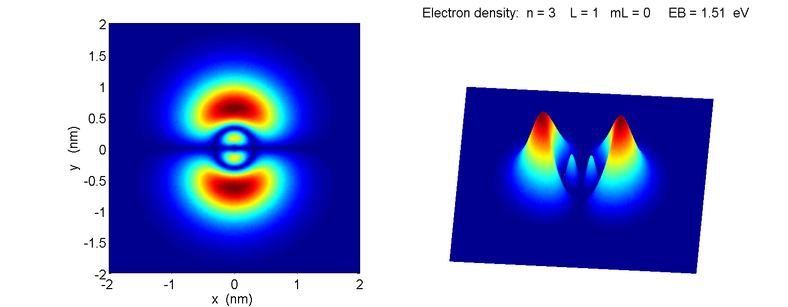

**state 3p *n* = 3 *l* = 1 *ml* = ±1** 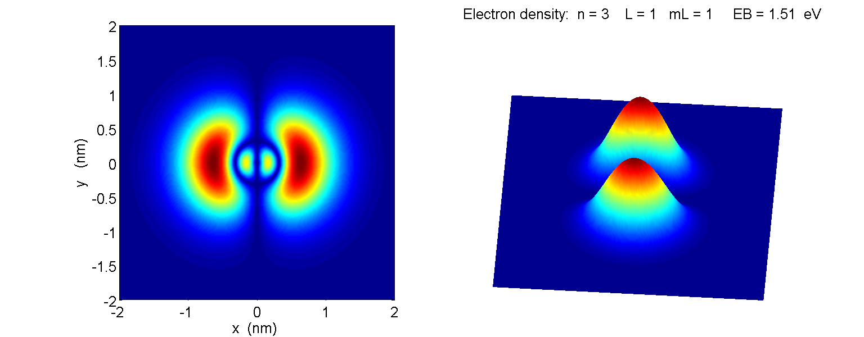

**state 3d *n* = 3 *l* = 2 *ml* = 0** 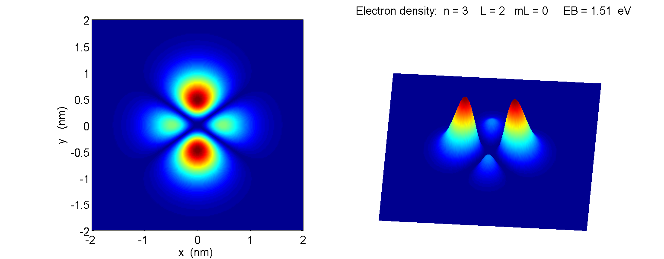

**state 3d *n* = 3 *l* = 2 *ml* = ±1** 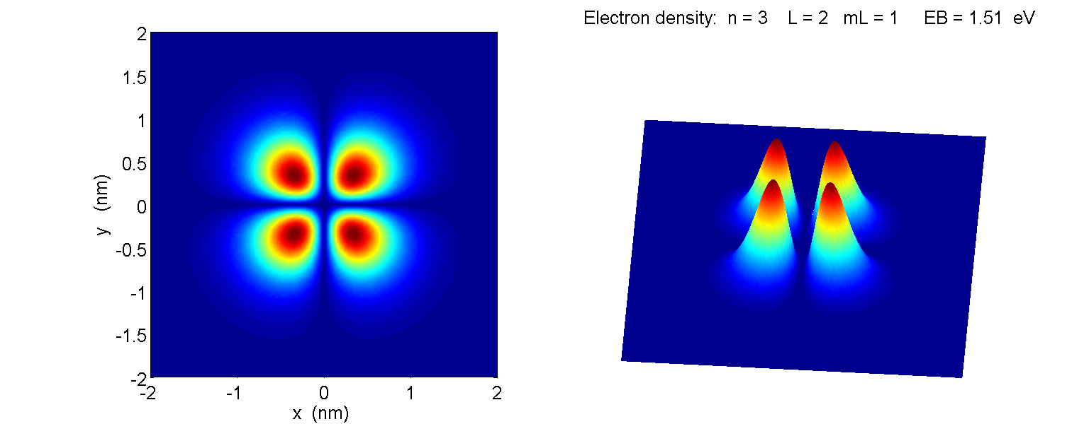

**state 3d *n* = 3 *l* = 2 *ml* = ±2** 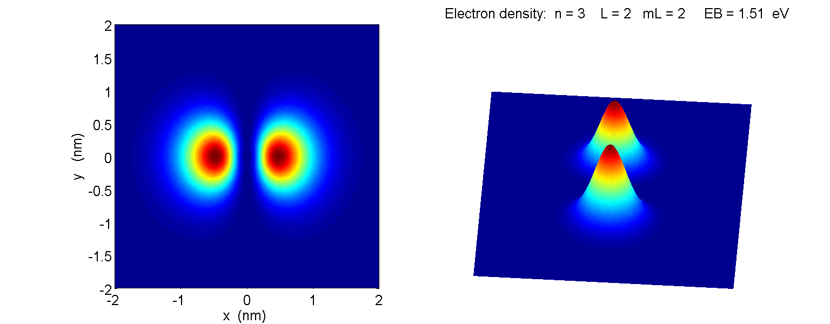

**state 4s *n* = 4 *l* = 0 *ml* = 0** 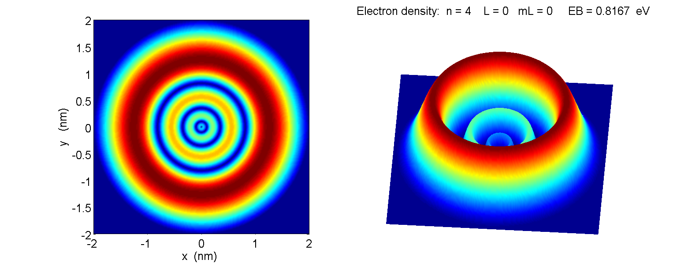

**state 4p *n* = 4 *l* = 1 *ml* = 0** 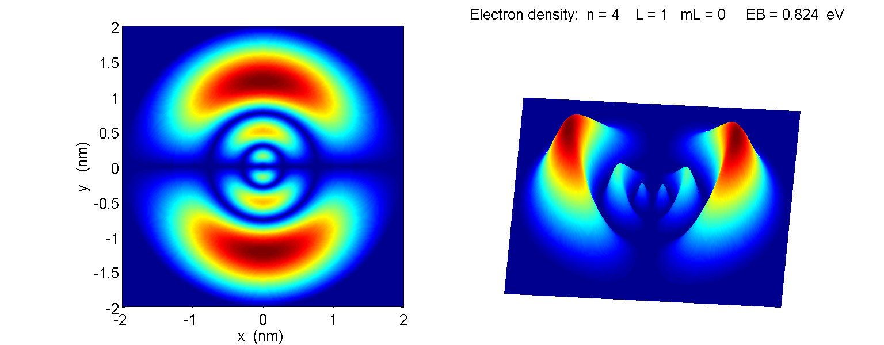

**state 4p *n* = 4 *l* = 1 *ml* = ±1** 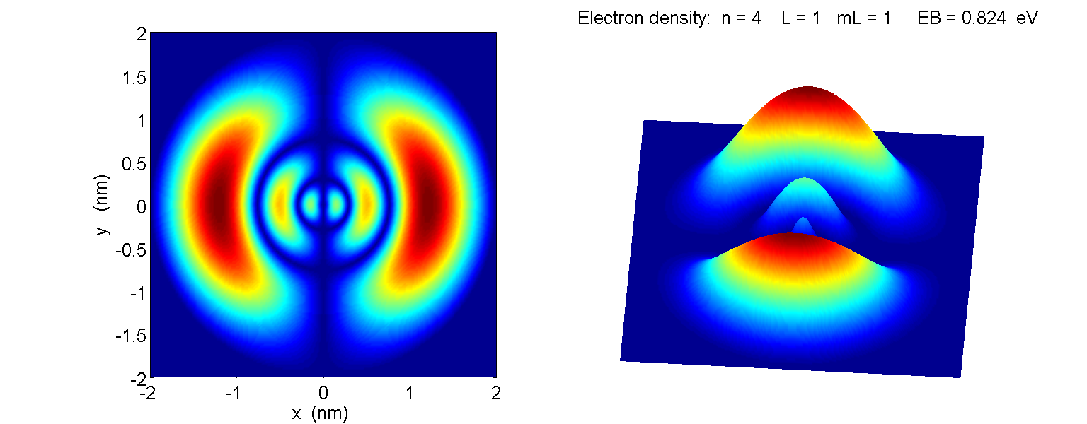

**state 4d *n* = 4 *l* = 2 *ml* = 0** 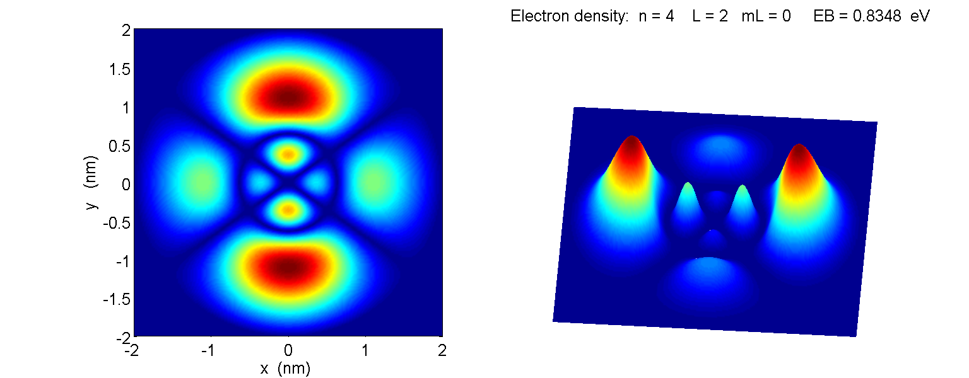

**state 4d *n* = 4 *l* = 2 *ml* = ±1** 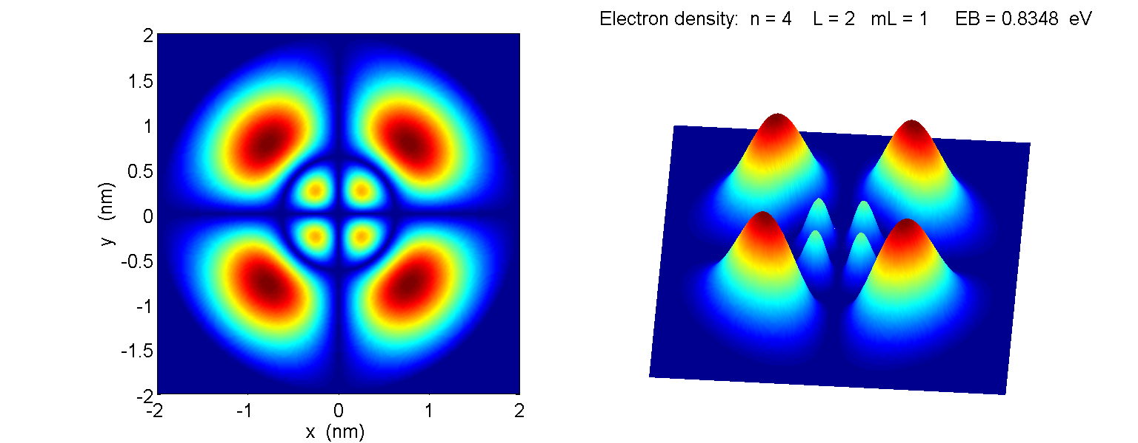

**state 4d *n* = 4 *l* = 2 *ml* = ±2** 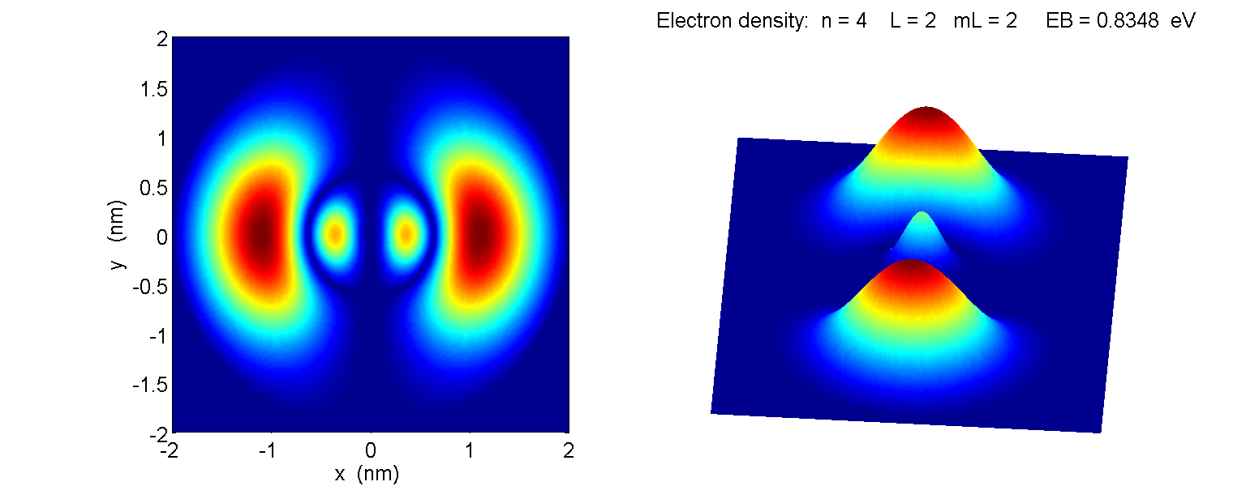

**state 4f *n* = 4 *l* = 3 *ml* = 0** 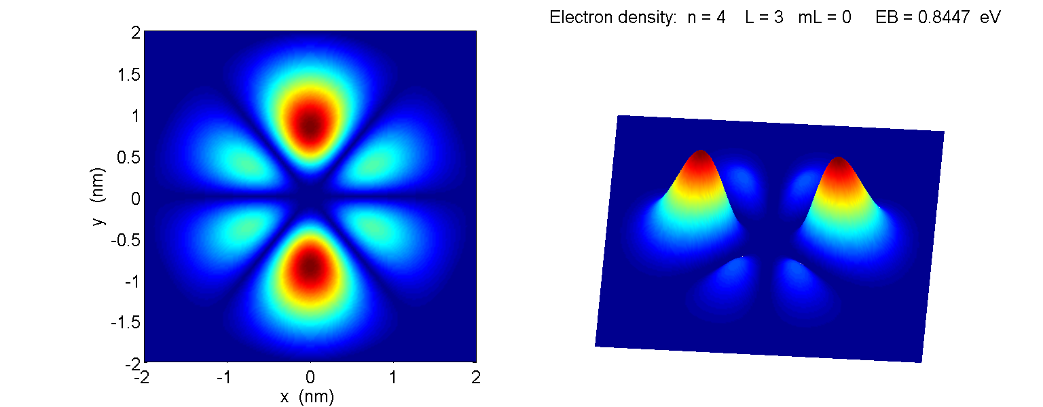

**state 4f *n* = 4 *l* = 3 *ml* = ±1** 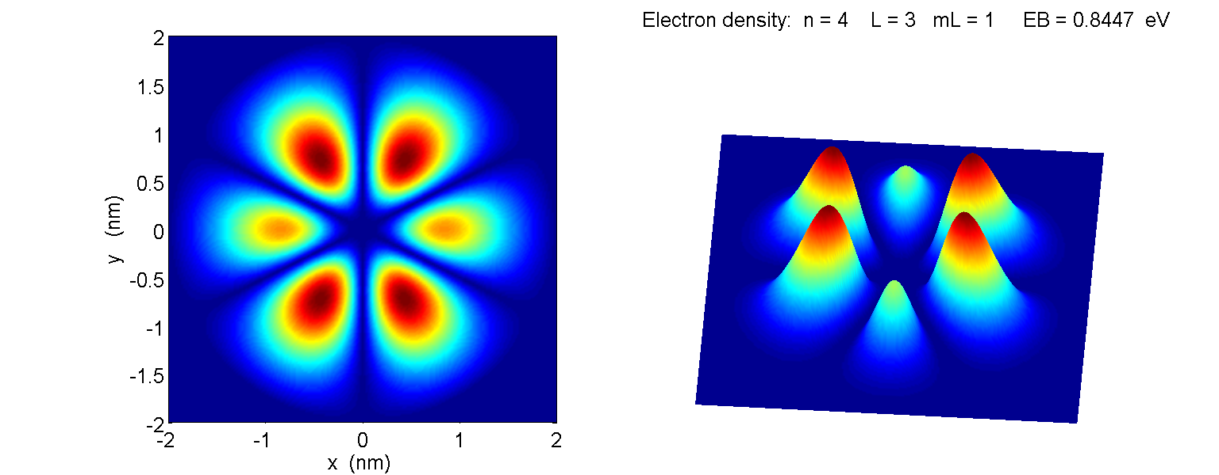

**state 4f *n* = 4 *l* = 3 *ml* = ±2** 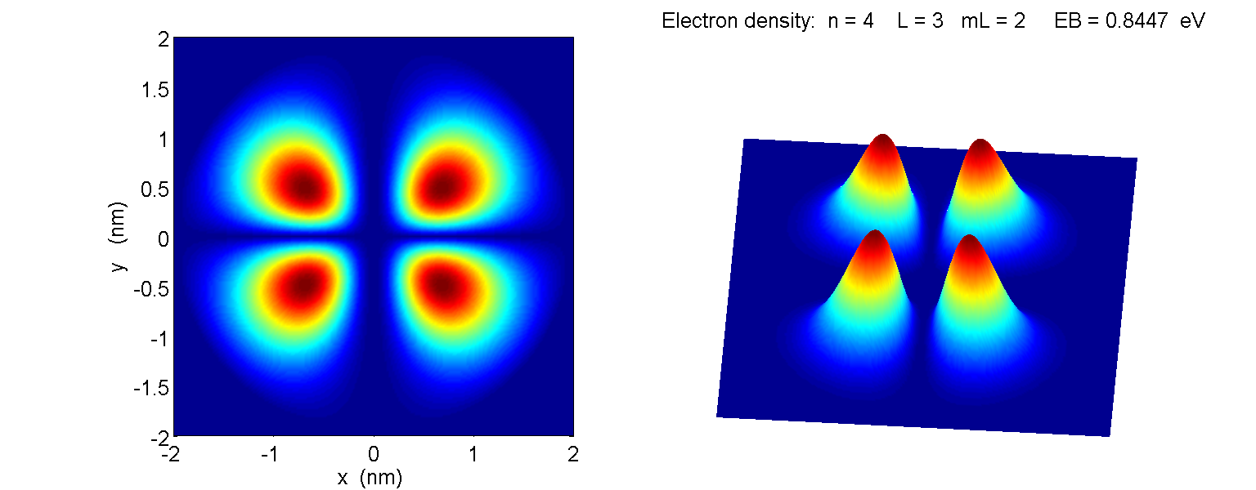

**state 4f *n* = 4 *l* = 3 *ml* = ±3** 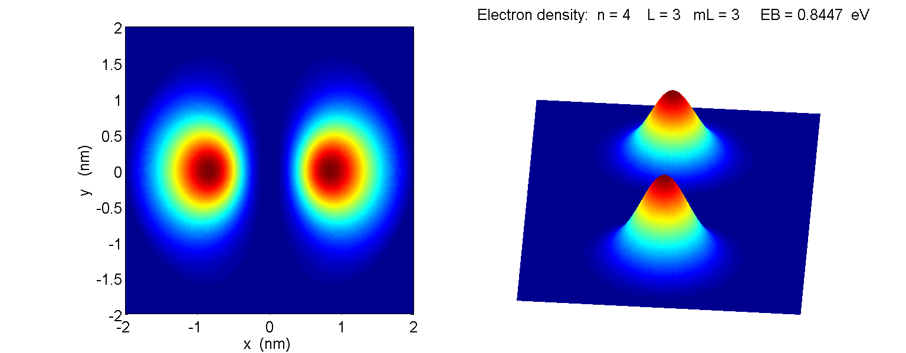

**Single electron ions He+ and Li++**

Both the helium ion He+ and lithium ion Li++ can be modelled as single electron atoms. In the modelling the mass of the electron is used and not the reduced mass of the electron and nucleus. The only variable that needs to be change from the hydrogen simulations is the atomic number: *Z*(H) = 1 Z(He+) = 2 Z(Li++) = 3.

In each case, the shapes of the wavefunction for all combinations of *n*, *l* and *ml* are the same since all three species can be modelled as single electron.

The main difference between the three species are the binding energies *EBn* of the electron (*EBn* = -*En*) and the radius *rMost Prob* for the maximum probability concentration for the maximum *l* value (*l* = *n*-1) which corresponds quite well with the Bohr radius *rn*.

The Bohr model gives equation (8) for the binding energy of the electron (same result as derived from the solution of the Schrodinger Equation) and the equation (9) for the allowed stable circular orbits of the electron.

(8) 

(9) 

Matlab can be used to draw line spectrum diagram. The mscript **qp_balmer.m** was used to show the line emission spectrum for the **Balmer series** (final state *nf* = 2).

**BALMER SERIES**

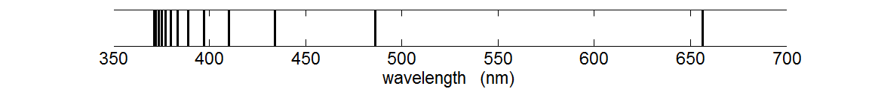

The following tables compare the calculation from equations (8) and (9) using the mscript **qp_bohr.m** with the simulations using **qp_hydrogen.m**. The simulations used *ml* = 0 and

H *rmax* = 60x10-10 m He+ *rmax* = 30x10-10 m Li++ *rmax* = 30x10-10 m .

Table 3A

|  |  |  |  |  |
| --- | --- | --- | --- | --- |
|  | **H (Bohr)** | | **H (simulation)** | |
| *n* | *EB* (eV) | *rn* (x10-10m) | *EB* (eV) | *rn* (x10-10m) |
| 1 | 13.605 | 0.529 | 13.559 | 0.550 |
| 2 | 3.401 | 2.112 | 3.400 | 2.110 |
| 3 | 1.512 | 4.763 | 1.510 | 4.750 |
| 4 | 0.850 | 8.467 | 0.849 | 8.500 |
| 5 | 0.544 | 13.230 | 0.544 | 13.25 |
| 6 | 0.378 | 19.051 | 0.377 | 19.05 |
| 7 | 0.278 | 25.930 | 0.273 | 25.95 |
| 8 | 0.213 | 33.868 | 0.175 | 33.45 |
| 9 | 0.168 | 42.864 | 0.049 | 39.65 |
| 10 | 0.136 | 52.918 | --- | 43.45 |

Table 3A: There is excellent agreement between the Bohr theory predictions and those of the simulation up to about *n* = 7. For higher *n* values, inaccuracies occur because the forcing of the wavefunction to go to zero at a radial distance of *rmax* = 60x10-10 m, the maximum well was set at -1000 eV and the number of data points for the calculation was 1201.

Table 3B

|  |  |  |  |  |
| --- | --- | --- | --- | --- |
|  | **He+ (Bohr)** | | **He+ (simulation)** | |
| *n* | *EB* (eV) | *rn* (x10-10m) | *EB* (eV) | *rn* (x10-10m) |
| 1 | 54.419 | 0.265 | 53.827 | 0.275 |
| 2 | 13.605 | 1.058 | 13.531 | 1.050 |
| 3 | 6.047 | 2.381 | 6.023 | 2.375 |
| 4 | 3.401 | 4.234 | 3.391 | 4.250 |
| 5 | 2.177 | 6.615 | 2.171 | 6.625 |
| 6 | 1.512 | 9.525 | 1.508 | 9.525 |
| 7 | 1.111 | 12.965 | 1.092 | 12.98 |
| 8 | 0.850 | 16.934 | 0.697 | 16.73 |
| 9 | 0.672 | 21.432 | 0.193 | 19.83 |
| 10 | 0.544 | 26.459 | --- | 21.73 |

Table 3B: There is excellent agreement between the Bohr theory predictions and those of the simulation up to about *n* = 6.

Table 3C

|  |  |  |  |  |
| --- | --- | --- | --- | --- |
|  | **Li++ (Bohr)** | | **Li++ (simulation)** | |
| *n* | *EB* (eV) | *rn* (x10-10m) | *EB* (eV) | *rn* (x10-10m) |
| 1 | 122.44 | 0.176 | 116.07 | 0.183 |
| 2 | 30.61 | 0.706 | 29.80 | 0.700 |
| 3 | 13.60 | 1.588 | 13.36 | 1.583 |
| 4 | 7.653 | 2.822 | 7.547 | 2.833 |
| 5 | 4.900 | 4.410 | 4.843 | 4.417 |
| 6 | 3.401 | 6.350 | 3.368 | 6.886 |
| 7 | 2.500 | 8.643 | 2.438 | 8.650 |
| 8 | 1.913 | 11.29 | 1.548 | 11.12 |
| 9 | 1.512 | 14.29 | 0.407 | 13.22 |
| 10 | 1.224 | 17.63 | --- | 14.22 |

Table 3C: The agreement between the Bohr theory predictions and those of the simulation is not so good. One always needs to be careful using numerical methods because the model can often give unacceptable results and you may not be aware of them. For these results, the number of data points for the calculation was 1201 and the potential energy function was truncated at -1000 eV. The total energy for the ground state is -122 eV and so in this model the potential well was not deep enough. To improve the model, the maximum depth of the potential well was set to -5000 eV and the number of data points was increased to 2201. This increased the execution time by a factor of 2. The results of the improved model are given in Table 3D.

Table 3D

|  |  |  |  |  |
| --- | --- | --- | --- | --- |
|  | **Li++ (Bohr)** | | **Li++ (simulation)** | |
| *n l* | *EB* (eV) | *rn* (x10-10m) | *EB* (eV) | *rn* (x10-10m) |
| 1 0 | 122.44 | 0.176 | 122.1 | 0.175 |
| 2 1 | 30.61 | 0.706 | 30.56 | 0.700 |
| 3 2 | 13.60 | 1.588 | 13.59 | 1.600 |
| 4 3 | 7.653 | 2.822 | 7.64 | 2.825 |
| 5 4 | 4.900 | 4.410 | 4.89 | 4.425 |
| 6 5 | 3.401 | 6.350 | 3.40 | 6.350 |
| 7 6 | 2.500 | 8.643 | 2.50 | 8.650 |
| 8 7 | 1.913 | 11.29 | 1.91 | 11.30 |
| 9 8 | 1.512 | 14.29 | 1.46 | 14.30 |
| 10 9 | 1.224 | 17.63 | 0.97 | 17.48 |

Table 3D: There is an excellent agreement between the theoretical predictions and results of the simulation. The improved accuracy compared with Table 3C was the depth of the potential well was much deeper when truncated.

In comparing the results in tables 3, the binding energies increase with greater nuclear charge (hydrogen +1, helium +2 and lithium +3) and on average the electron is closer to the nucleus as expected because of the greater the coulomb attraction between the electron the a nucleus with greater positive charge.

**Neutral lithium atom Li**

The lithium atom (*Z* = 3) has a nucleus containing three protons and surrounding it are three electrons. The electronic configuration of lithium in its ground state is 1s2 2s1. The inner two most electrons are tightly bound to the nucleus in a complete shell. However the single 2s electron is only weakly bound. This 2s electron can be easily removed from the atom (very low ionization energy).

Successive ionization energies for the lithium atom:

1st 5.3917 eV 2nd 75.64 eV 3rd 122.45 eV

So we can model the neutral lithium atom in a similar manner to the hydrogen atom. The single 2s electron is bound to a +3 charged nucleus but this electron is screened from the nucleus by the two 1s electrons of total charge -2. In a simple model, we can use an effective *Zeff* value to account for the nuclear charge and the screening effect for the two inner most electrons in running our simulation. For the outer most (valence) electron, the ground state is 2s and the higher states are 2p, 3s, 3p, 3d, 4s, 4p, 4d, 4f, … . There is also some electron-electron repulsion, but this is generally not significant.

The binding energies for the states of the outer electron are given in Table 4. In running the simulations, the goal is to find the value of effective nucleus charge given by *Zeff* by a trial-and-error approach by matching the computed binding energy for a state with the accepted value.

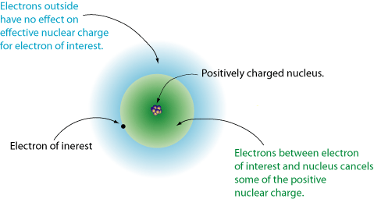

Fig. 9. The valence electron is screened from the full effects of the charge on the nucleus.

<http://www.grandinetti.org/resources/Teaching/Chem121/Lectures/MultiElectronAtoms/multielectron.gif>

Table 4 *rmax* = 60x10-10 m

|  |  |  |  |  |  |
| --- | --- | --- | --- | --- | --- |
| **State** | **hydrogen**  ***E*B (eV)**  ***Z* = 1** | **Lithium**  ***EB* (eV)**  ***theory*** | **Lithium**  ***EB* (eV)**  ***simulation*** | ***Zeff***  ***simulation*** | ***Zeff***  **web**  **searchs** |
| **1s** | 13.56 | --- |  |  |  |
| **2s** | 3.40 | 5.39 | 5.39 | 1.26 | 1.28 |
| **2p** | 3.40 | 3.54 | 3.47 | 1.01 | 1.00 |
| **3s** | 1.51 | 2.02 | 2.01 | 1.155 | 1.155 |
| **3p** | 1.51 | 1.56 | 1.56 | 1.015 | 1.0144 |
| **3d** | 1.51 | 1.51 | 1.51 | 1.000 | 1.000 |
| **4s** | 0.85 | 1.05 | 1.06 | 1.115 |  |
| **4p** | 0.85 | 0.867 | 0.867 | 1.010 |  |
| **4d** | 0.85 | 0.852 | 0.853 | 1.002 |  |
| **4f** | 0.85 | 0.848 | 0.849 | 1.000 |  |

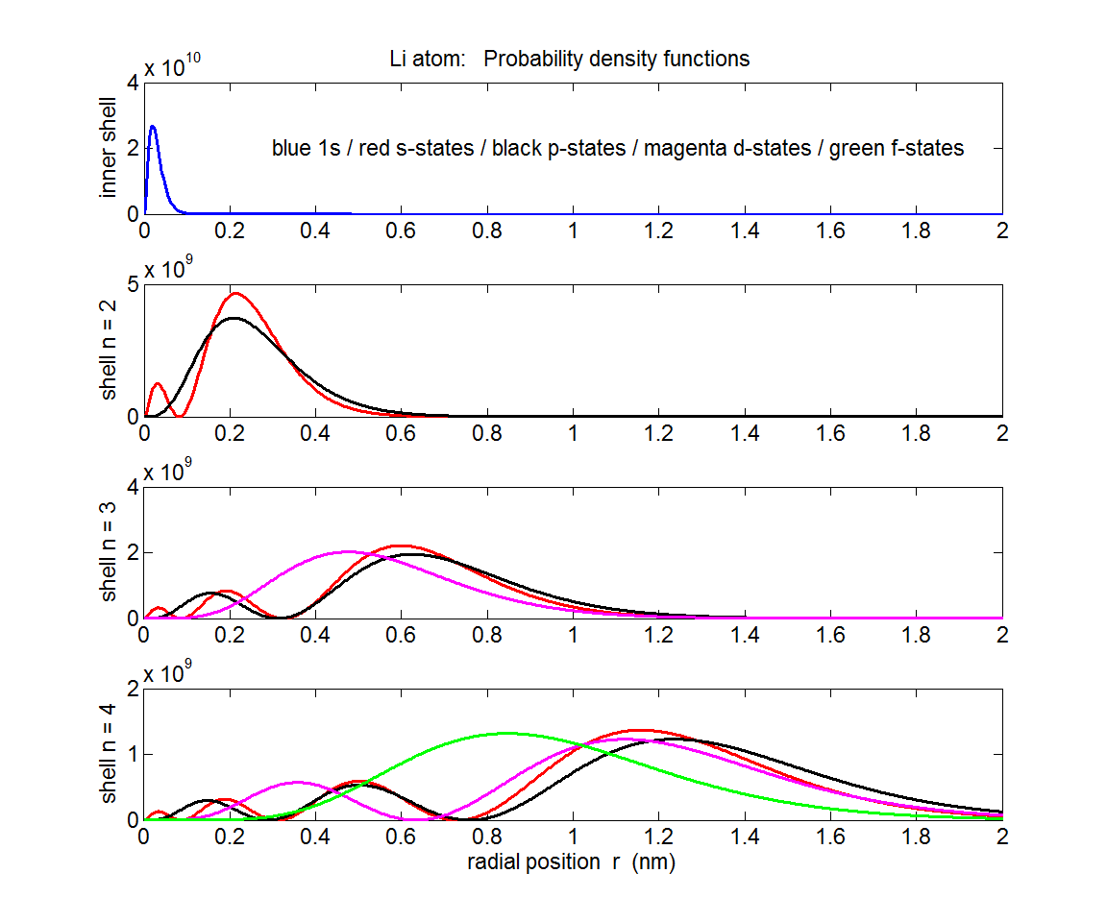

Fig. 10. Plots of the probability function for the neutral lithium atom.

mscript **qp_lithium.m** data file **qp_hL.mat**

In figure (10), the top plot shows the approximate probability density for the 1s state where the two inner most electrons screen the valence electron from the nuclear charge. The red curves are for s-sates, the black curves for the p-states, magenta for the d-states and green for the f-states. The wavefunction for each state was found by executing the mscript **qp_hydrogen.m**. The values for the wavefunction psi for each state were saved one at a time in a data file using the save command; for example the wavefunction for the 4f state *(n* = 0, *l* = 3, *ml* = 0, *Zeff* = 1) was assigned to the variable p4f in the Command window by p4f = psi(:,qn) after running the mscript qp_hydrogen.m and then saved in the file **qp_lithium.mat** using the command save(`qp_lithium`,`-append`,`p4f`).

We see that there is a greater **overlap** between the orbitals for the two 1s electrons and the 2s orbital compared with the 2p orbital and so for 2p electron there is greater shielding (figure 11). The probability of finding the 3d electron inside the core is small, for a 3p electron the probability is slightly larger and for the 3s electron it is much larger still. Clearly, for an electron inside the core the effective nuclear charge is substantially greater than for an electron outside for which *Zeff* ≈ 1. If the electron lies within the stronger field, there is a greater coulomb attraction, hence, its associated binding energy is expected to be greater.

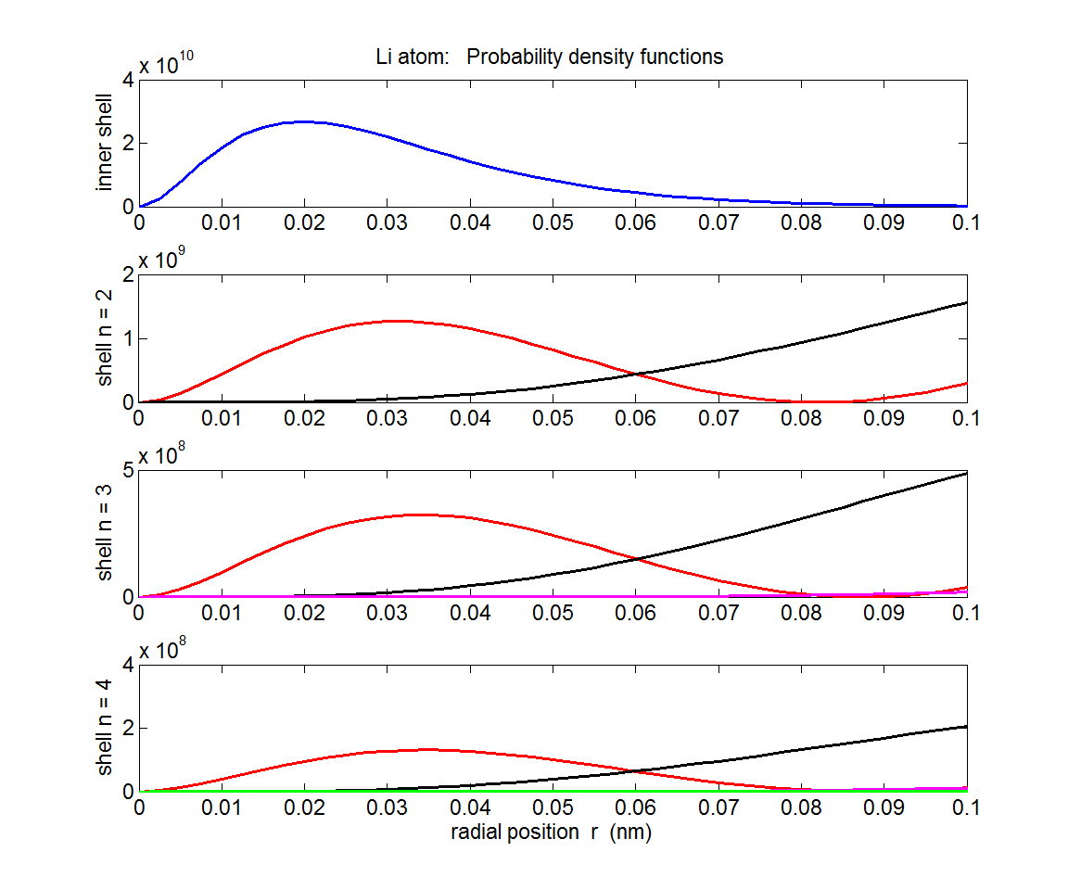

Fig. 10. Plots of the probability function for the neutral lithium atom in the region to show the overlap of the wavefunctions near the nucleus..

mscript **qp_lithium.m** data file **qp_hL.mat**

The order of the shielding effects are:

2s < 2p 3s < 3p < 3d 4s < 4p < 4d < 4f

and so the binding energies are order as:

2s > 2p 3s > 3p > 3d 4s > 4p > 4d > 4f

That is, for a given principle quantum number *n*, the states of higher angular momentum (higher *l*) have lower binding energies than those of smaller angular momentum in multi-electron atoms.

For atoms such potassium the ordering of the binding energies is not so straight forward because of the shielding effects. In potassium the binding energy of the 4s state is greater than the 3d state whereas in hydrogen , the *n* = 4 levels all have less binding energies than the n = 3 levels.